**Assignment 5**

→Fork an existing repository created during the course

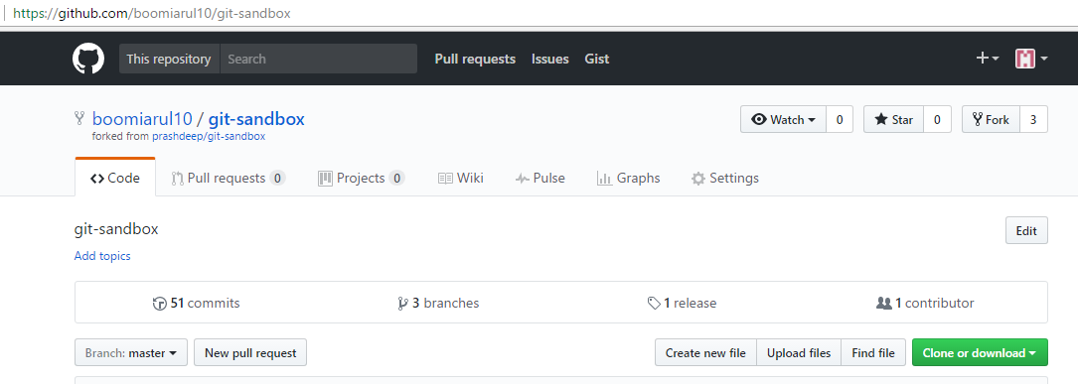→ Clone the repository from the forked repository onto local machine

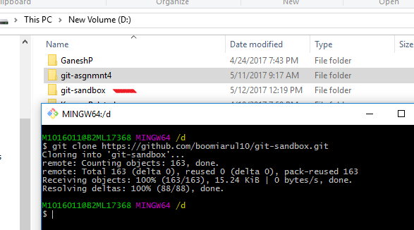

→ Make the changes and push the changes to the remote repository

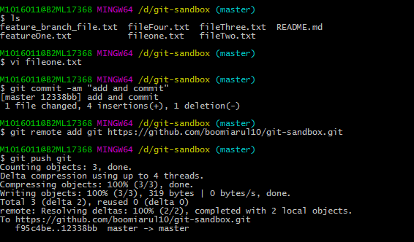

→ Create a pull request and create a discussion to merge the changes to the central repository

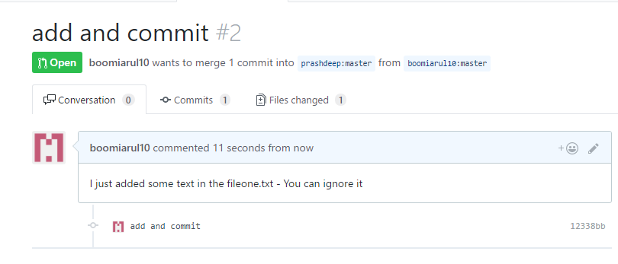

→ Fork from different repository and try to merge the pull request from other collaborators

